Tracking setting of platform: www.gps1199.com
（1）Restore factory settings, pass word: 1122 (must)

（2）Set the mobile number of administrator and guardian (must)
Format(command): Admin, Password, AdminTel,Tel1,Tel2
The default password of Tracking Watch is: 000000. AdminTel is the mobile number of administrator; Tel1,Tel2 are the moblie number of guardians. After setting , Tracking Watch will automatically send the SMS to the administrator’s mobile number. This command can be set and modified only by the administrator’s mobile number.
For example: administrator’s mobile number send such kind of SMS :
admin,000000,15960008888, 15960008887, 15960008886
to SIM card number in Tracking Watch, then 15960008888 will be set as administrator’s mobile number of Tracking Watch. administrator’s mobile number will be same as the main Guardian’s number, 15960008887 will be tel1, 15960008886 will be the tel2. When all setting finished, there will be a SMS back to inform the main guardian
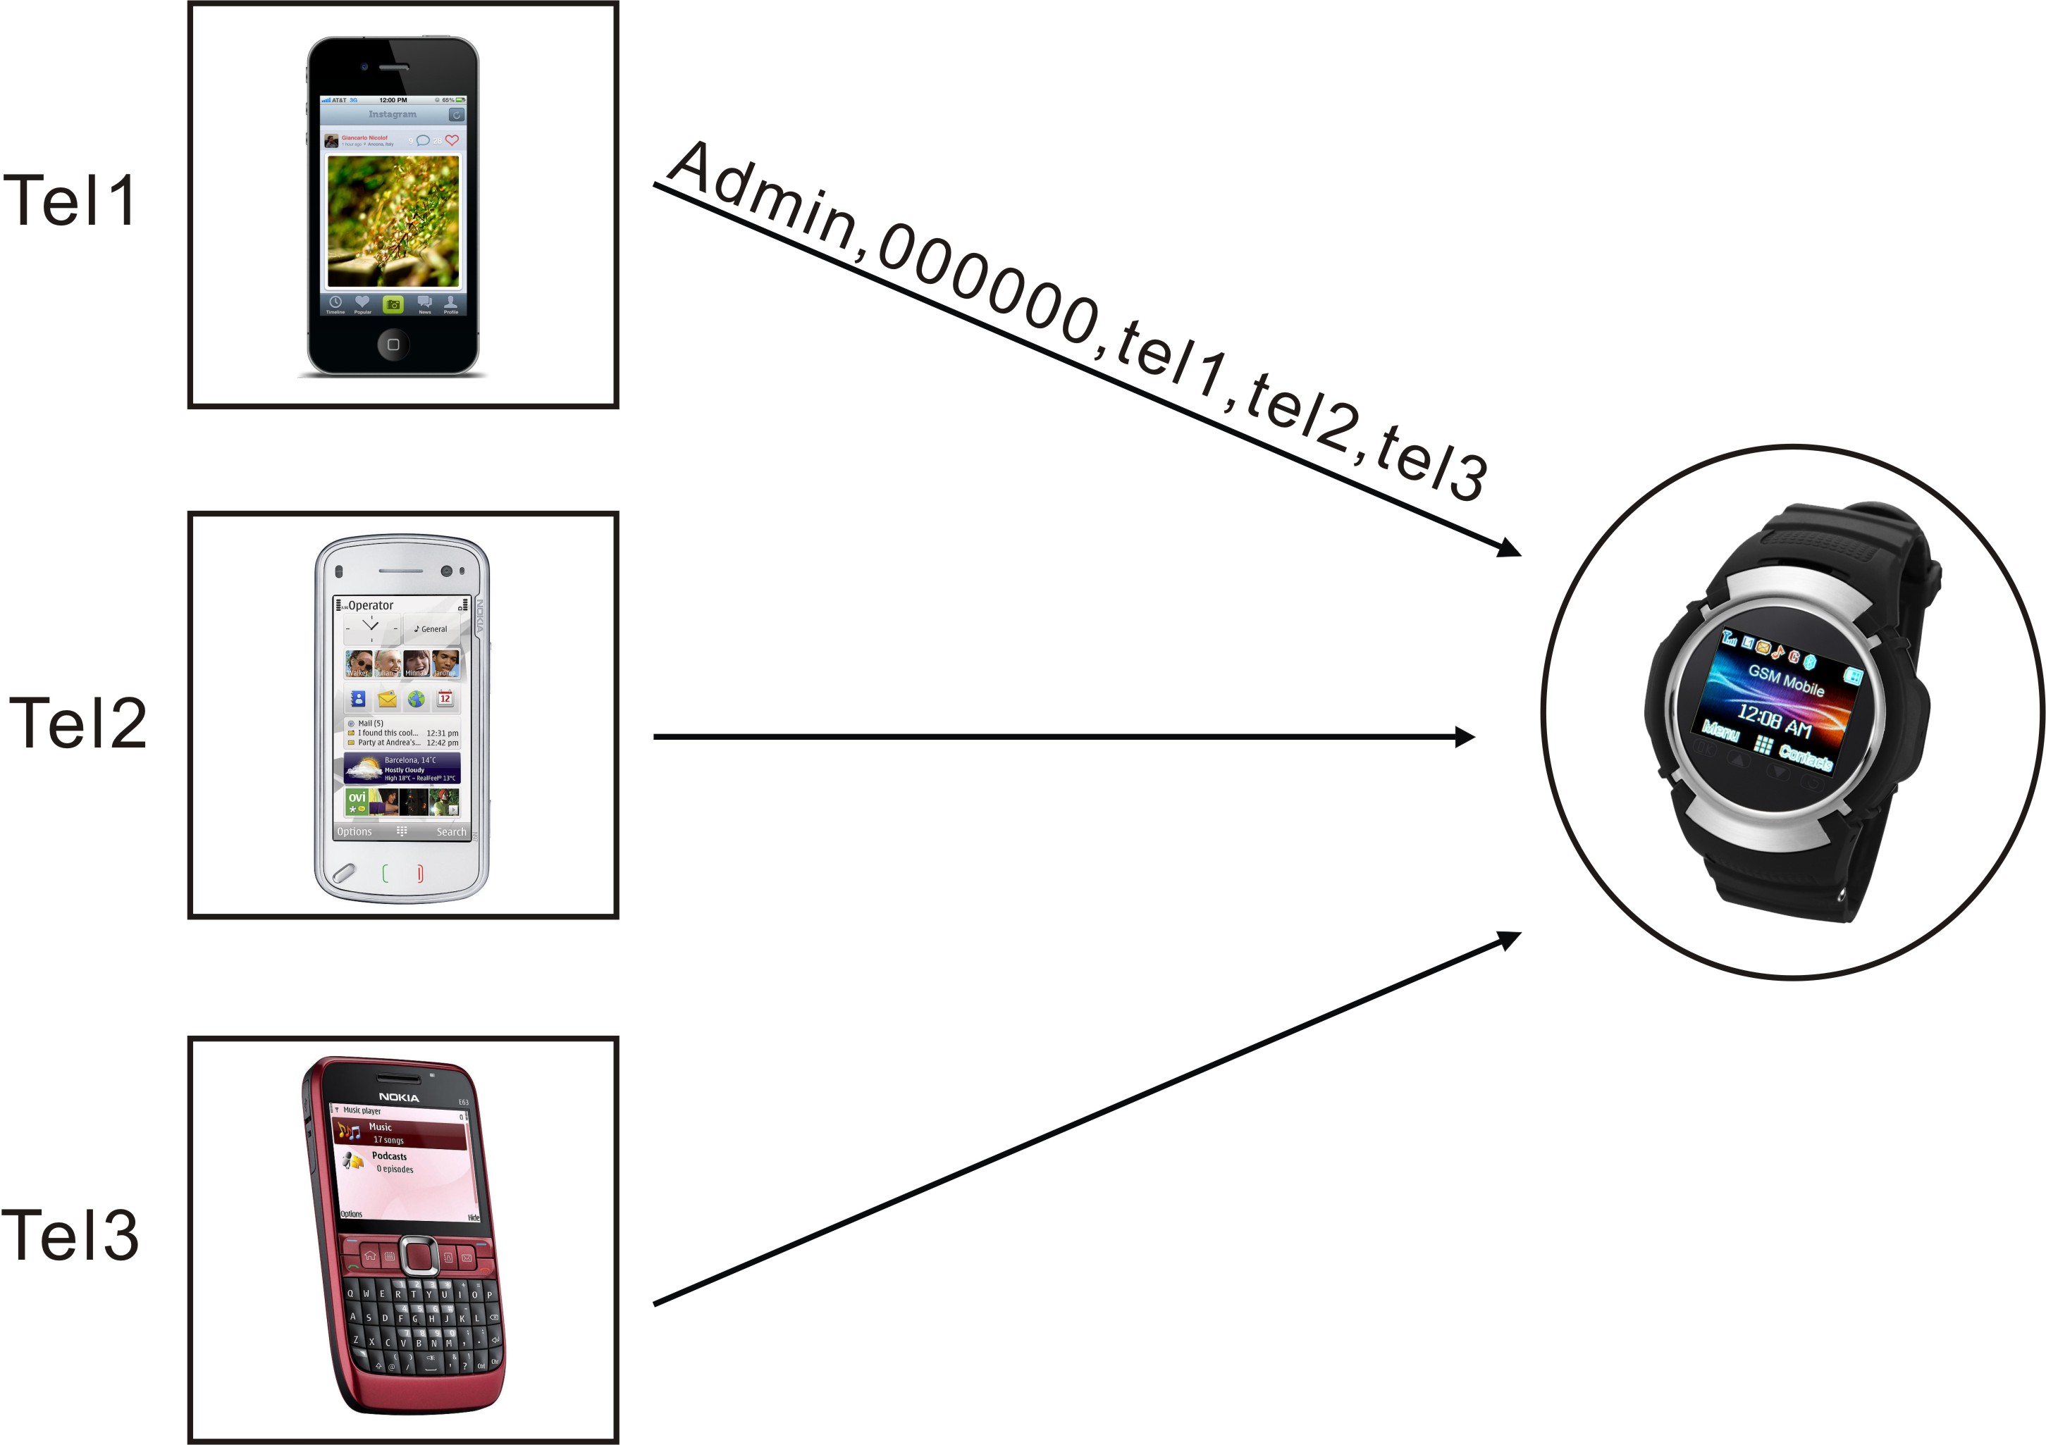

（3） Setting Tracking Mode(must)
Format(command): mode, password, interval of realtime tracking, times of return.
Set interval of timing return and frequency of return, interval as 0 means time to time return, frequency as 0 means return the data to “Position Online” Platform with unlimited times. This order just can be set and modified by administer.
For example: administrator’s mobile number send such kind of SMS:
mode,000000,180,0
to SIM card in Tracking Watch, then the Tracking Watch return the data to “Position Online” Platform with unlimited times every 180 secs.
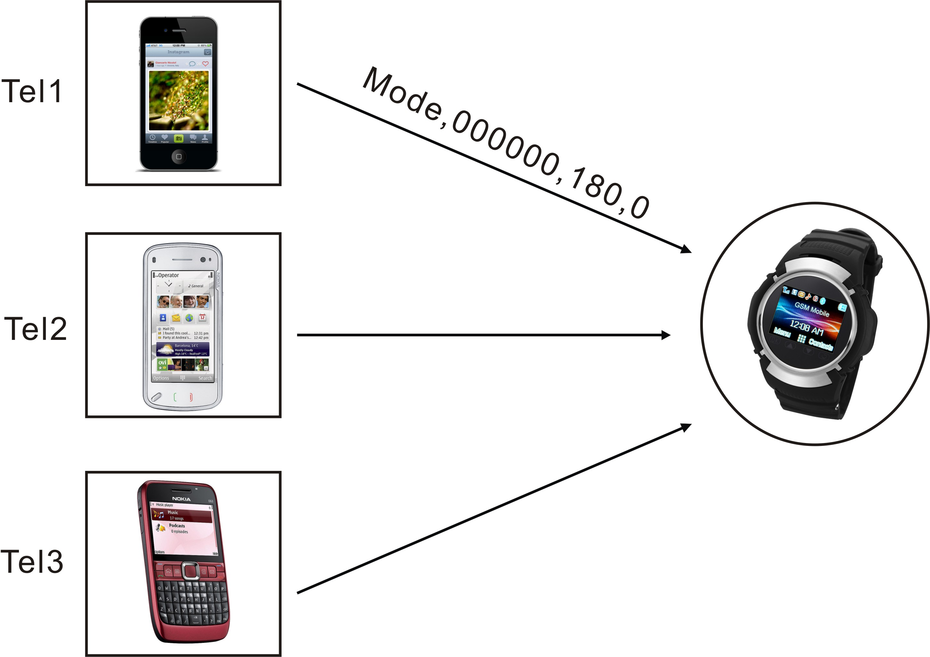

（4） Setting IP（must）---- very important ,pls attention
Format(command)：ip,220.231.142.129,5036
Use the Tel1( note: not the administrator number) send such a kind of SMS：ip,220.231.142.129,5036
to the watch。---use second guardian phone number to send “ip,220.231.142.129,5036” to the watch number.
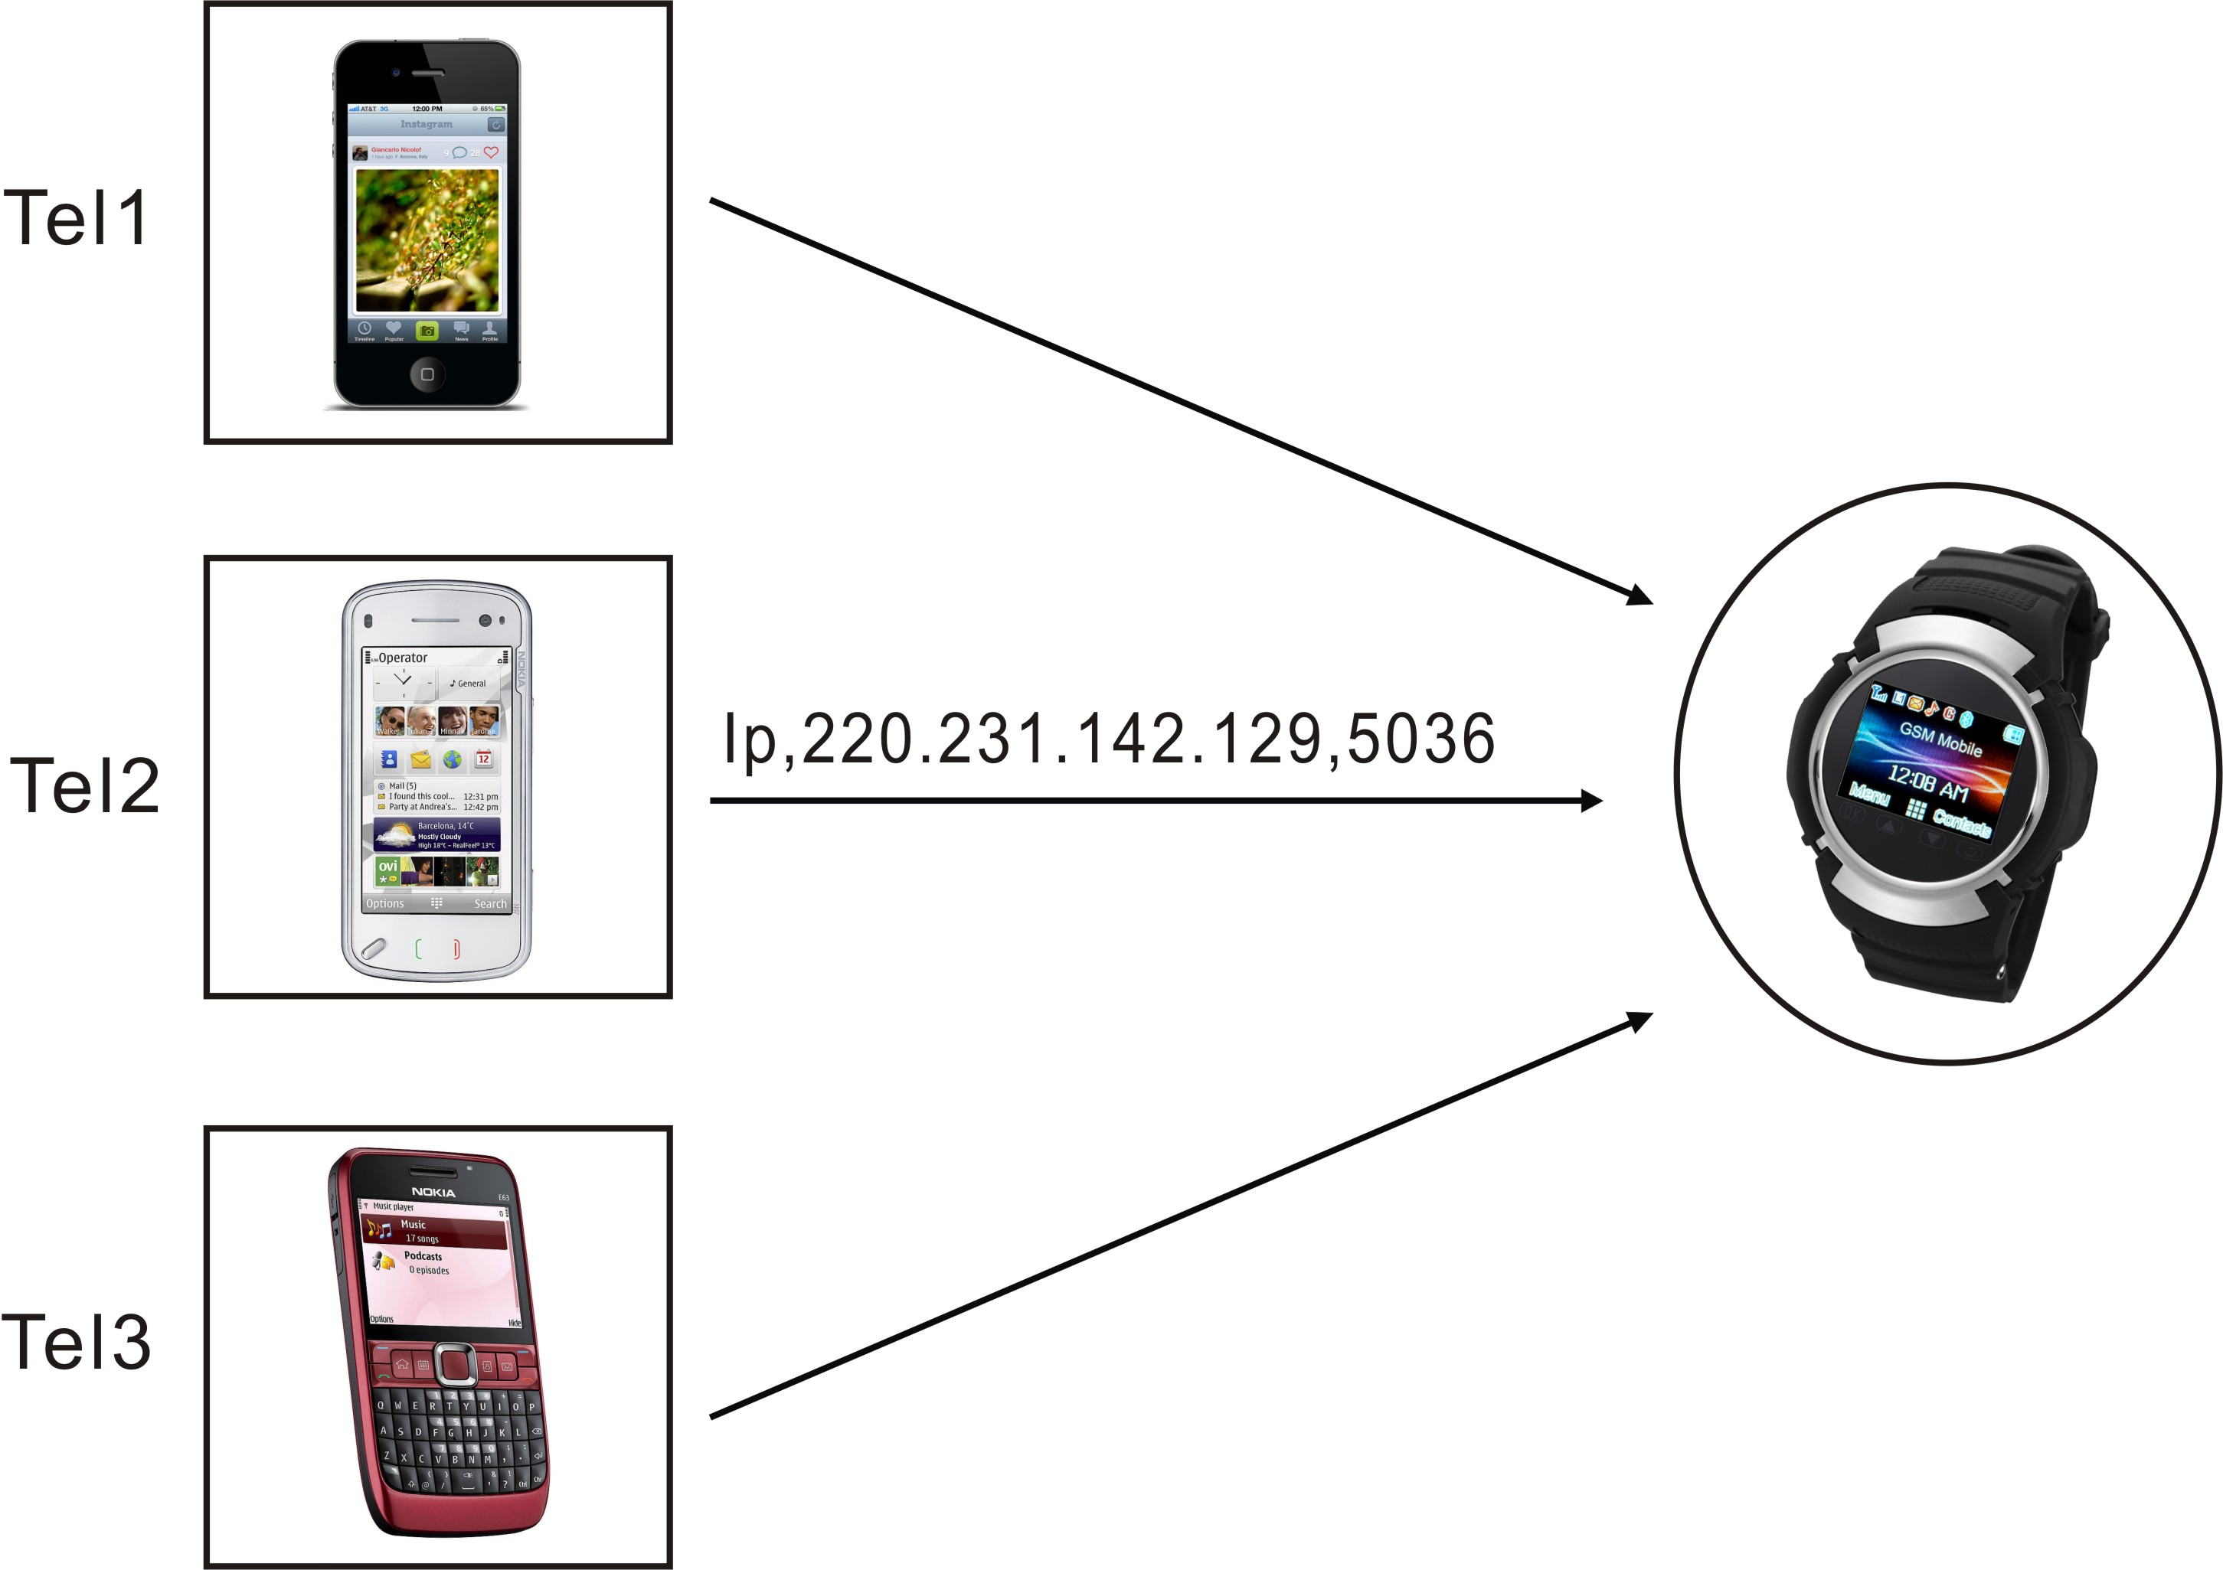

After all the above 4 setting then you can tracking our watch on our platform website.

